SAMPLE FUNDRAISING LETTER

Date

Company
Attention:
Company Address
Company City, State, Zip)

Dear Community Partner:

Angelman Syndrome (AS) is a rare neurodevelopmental disorder that you may not have heard of – yet. Unlike cancer and other diseases, we know exactly what causes AS. Our researchers are actively working on different studies with some very encouraging results. Current efforts include a brain-imaging study and research into drugs or other therapies that can activate the dormant gene without affecting other genes. We are also working with pharmaceutical companies have begun clinical trials. One clinical trial through OVID Therapeutics was recently announced. The AS community has much hope for breakthrough treatments and a cure in our lifetime.

This is why I am reaching out to you today—the Angelman Syndrome Foundation (ASF) is edging ever closer to a cure, and I want to help make a difference for (insert, my son/daughter, or other) who has AS. (Insert description of your event with date/time/location)

Let’s make a difference together for so many kids! Partnership opportunities associated with (insert name of your event) are tax-deductible and will provide outstanding national & local exposure for (company name). Other opportunities are also available for ongoing partnership. Please review the enclosed corporate Partnership form for details. We accept all donations, no matter the level. I am happy to discuss details and answer any questions. I hope you will join with us as together we provide hope, support and encouragement for everyone touched by Angelman syndrome – Because you care, they have hope!

Sincerely,

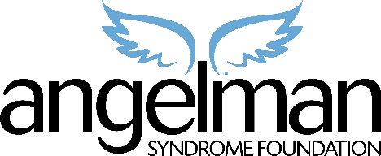
(Your Name Here)
Fundraising Coordinator
_{Give them a reason to smile!}

_{Enclosures}
Your ASF contribution is tax deductible under 501 (c)(3) of the IRS code to the extent allowable by law. Florida Registration #CH4382.

“Compared to 30 other pediatric neurological disorders, I would make the case that Angelman syndrome is at the top – it is THE single-most optimistic possibility for a cure.”
--Dr. Art Beaudet, Angelman syndrome researcher responsible for identifying the EBE3A gene

