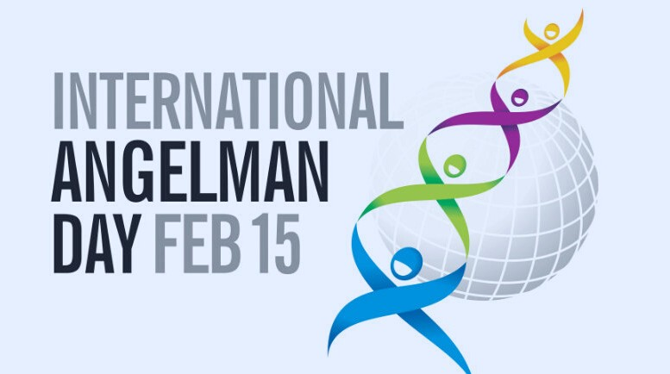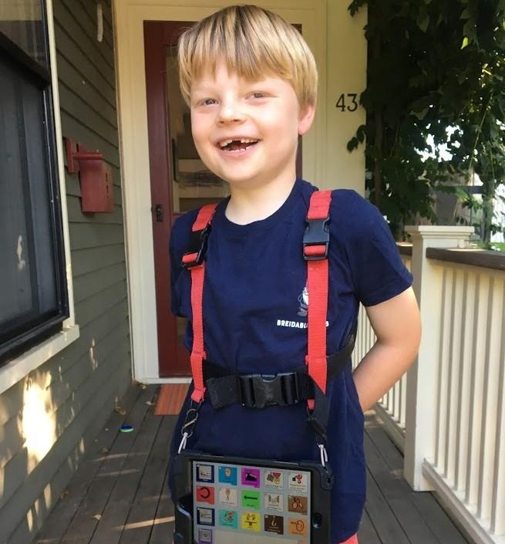Spreading Awareness for Angelman Syndrome Globally

Angelman.org/iad-2021
Brody, 6

