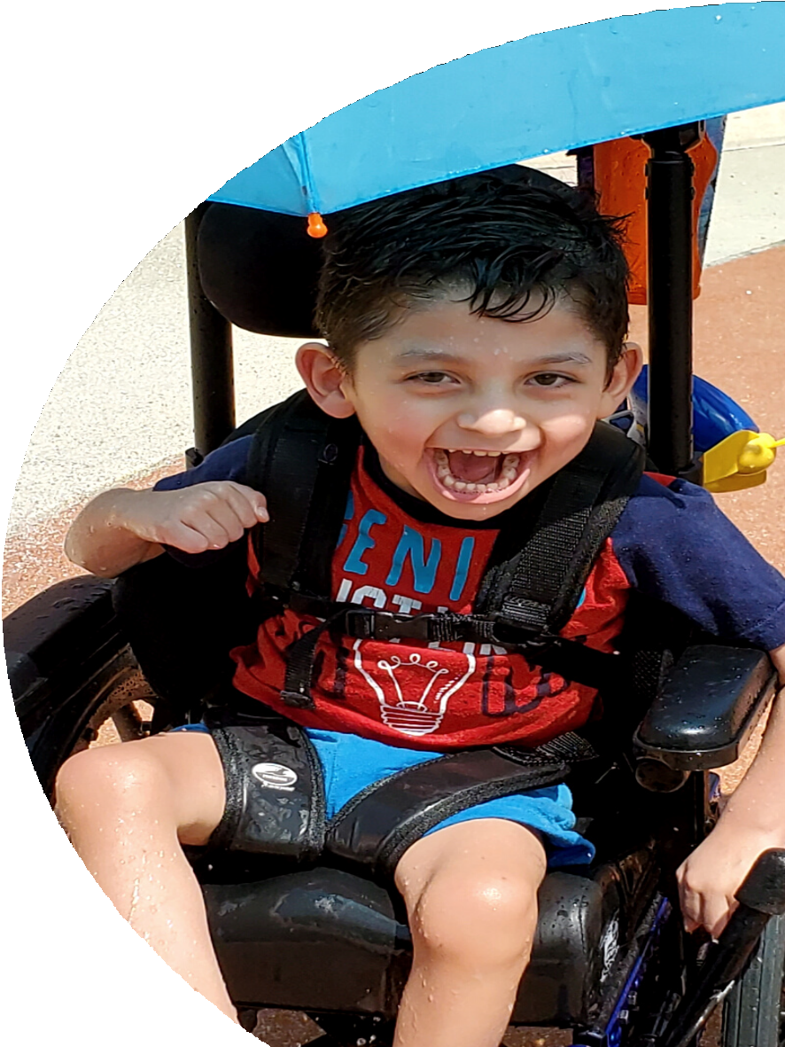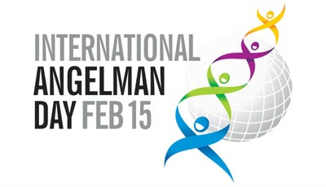

FEBRUARY 15TH

International Angelman Day
What is Angelman Syndrome? Angelman syndrome (AS) is a rare neuro- genetic disorder that occurs in one in 15,000 live births or 500,000 people worldwide. It is caused by a loss of function of the UBE3A gene in the 15th chromosome

People who have AS
face many daily challenges such as developmental delays, seizures, walking and balance disorders, gastrointestinal issues and little to no speech. They are best known for sharing their smiles and happy demeanor.

Name,age

