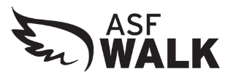
Company Name
Attention:
Company Address Company City, State, Zip)

Dear (Name):
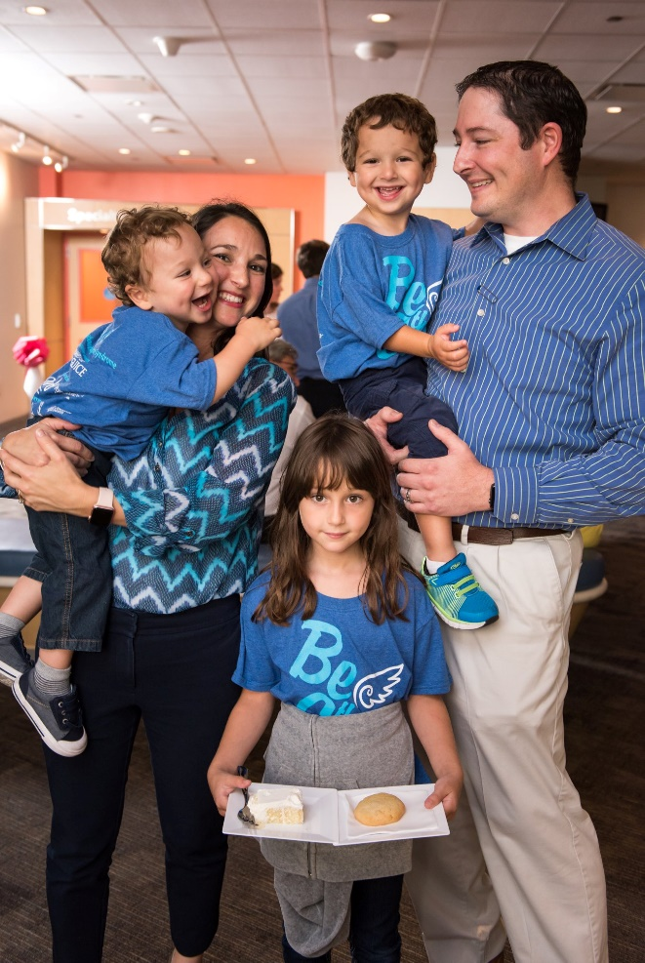

Angelman Syndrome (AS) is a rare neurodevelopmental disorder that you may not have heard of – yet. Unlike cancer and other diseases, we know exactly what causes AS.

(sample – Insert your story here) Alexander and Nicholas are two Angels that have made tremendous progress from struggling to walk to now running, from no words to now making sentences. They are a testament to the value of various therapies.

Our researchers are actively working on different studies with some encouraging results. The ASF National Walk is the largest annual fundraiser for the Angelman Syndrome Foundation (ASF), a 501c3 non-profit organization dedicated to improving the lives of individuals with Angelman syndrome through funding groundbreaking research, improving clinical care and supporting families. We have several exciting initiatives including a massive clinical trial network expansion set for 2021 and we need your support.

This is why I am reaching out to you today—we are edging ever closer to a cure, and we are energized.
Our 2021 ASF Walk is slotted to be in 53 locations across the continent on May 15, 2021.

At our Walk in <insert city name> we offer a raffle as an additional way to raise funds for AS. Please consider donating gift basket or item/gift card from your business for our raffle. We would truly appreciate any support your business can give. And, our local families are sure to remember your business when they are making their own purchases.

Did you know that children with Angelman syndrome, cannot talk, suffer from life-threatening seizures, have balance disorder and require little to no sleep? This necessitates near round the clock care to keep them safe. As a parent of a child with AS myself, I can tell you this is incredibly challenging and debilitating for our families. A safe place bed, sponsored by a corporate partner, can cost just $500 but can truly change a family’s life. This is just one of many things we can provide to a lucky family with your support.

I’d welcome the opportunity to talk further about this and other sponsorship level opportunities. Your help will bring us one step closer to finding a cure for this debilitating genetic disorder. Because you care, they have hope. You may also request additional information regarding AS at: 800-432-6435 or by visiting www.angelman.org.

Sincerely,

(Your Name Here), Fundraising Coordinator

