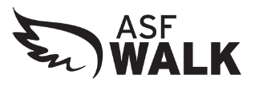

Dear (Insert Company/Individual Name):

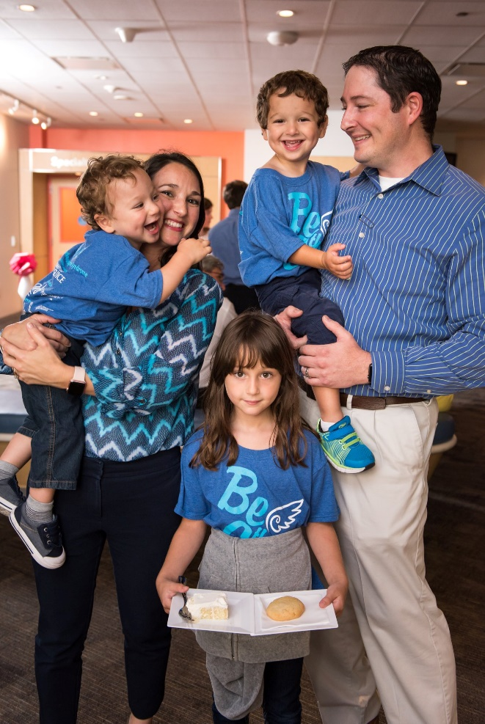
Angelman Syndrome (AS) is a rare neurodevelopmental disorder that you may not have heard of – yet. Unlike cancer and other diseases, we know exactly what causes AS.

Alexander and Nicholas are two Angels that have made tremendous progress from struggling to walk to now running, from no words to now making sentences. They are a testament to the value of various therapies.

Our researchers are actively working on different studies with some encouraging results. The ASF Walk is the largest annual fundraiser for the Angelman Syndrome Foundation (ASF), a 501c3 non-profit organization dedicated to improving the lives of individuals with Angelman syndrome through funding groundbreaking research, improving clinical care and supporting families.

This is why I am reaching out to you today—we are edging ever closer to a cure, and we are energized.
The 2023 ASF Walk will be in 50+ locations across the country on May 20, 2023.

Partnership opportunities associated with the 2022 ASF Walk are tax-deductible and will provide outstanding national & local exposure for Mallinckrodt Pharmaceuticals. Other opportunities are also available for ongoing partnership. Please review the enclosed corporate Partnership form for details. We accept all donations, no matter the level.

Did you know that children with Angelman syndrome, cannot talk, suffer from life-threatening seizures, have balance disorder and require little to no sleep? This necessitates near round the clock care to keep them safe. This is incredibly challenging and debilitating for our families. A safe place bed, sponsored by a corporate partner, can cost just $500 but can truly change a family’s life. This is just one of many things we can provide to a lucky family with your support.

I’d welcome the opportunity to talk further about this and other sponsorship level opportunities. Your help will bring us one step closer to finding a cure for this debilitating genetic disorder. Because you care, they have hope. You may also request additional information regarding AS at: 800-432-6435 or by visiting www.angelman.org.

Sincerely,

(your name), Montana ASF Walk Coordinator
Angelman Syndrome Foundation, Inc.

